Creating output bucket which stores cleaned data

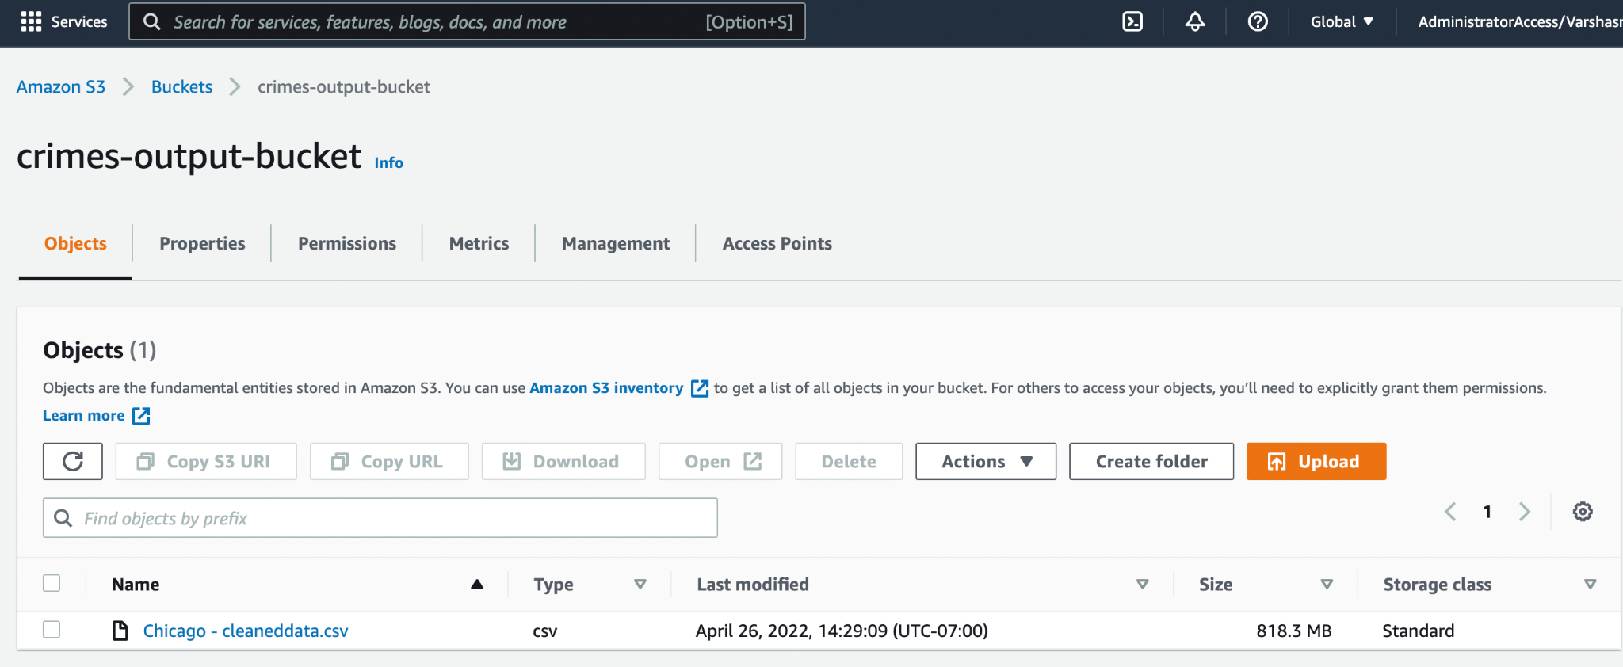

AWS Glue:

Created Glue crawler:

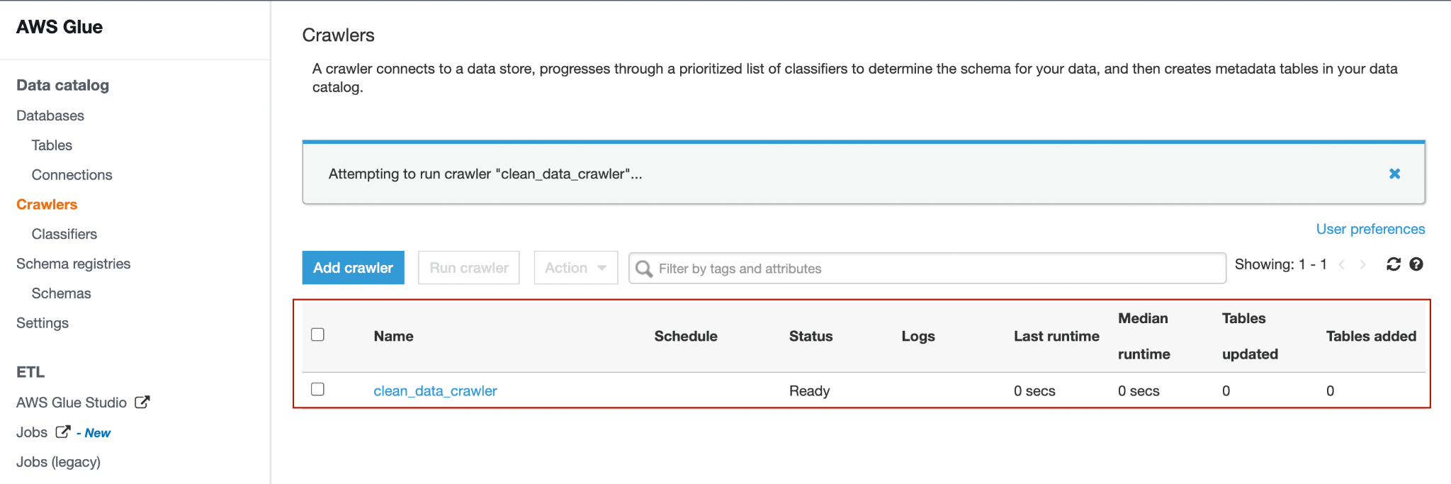

Created a database

* Cluster-remember password
* Cluster-create endpoint before establishing connection
* Cluster-gave access in properties(not sure)
* Crawler-updated extsting role
* Created crawler from databse

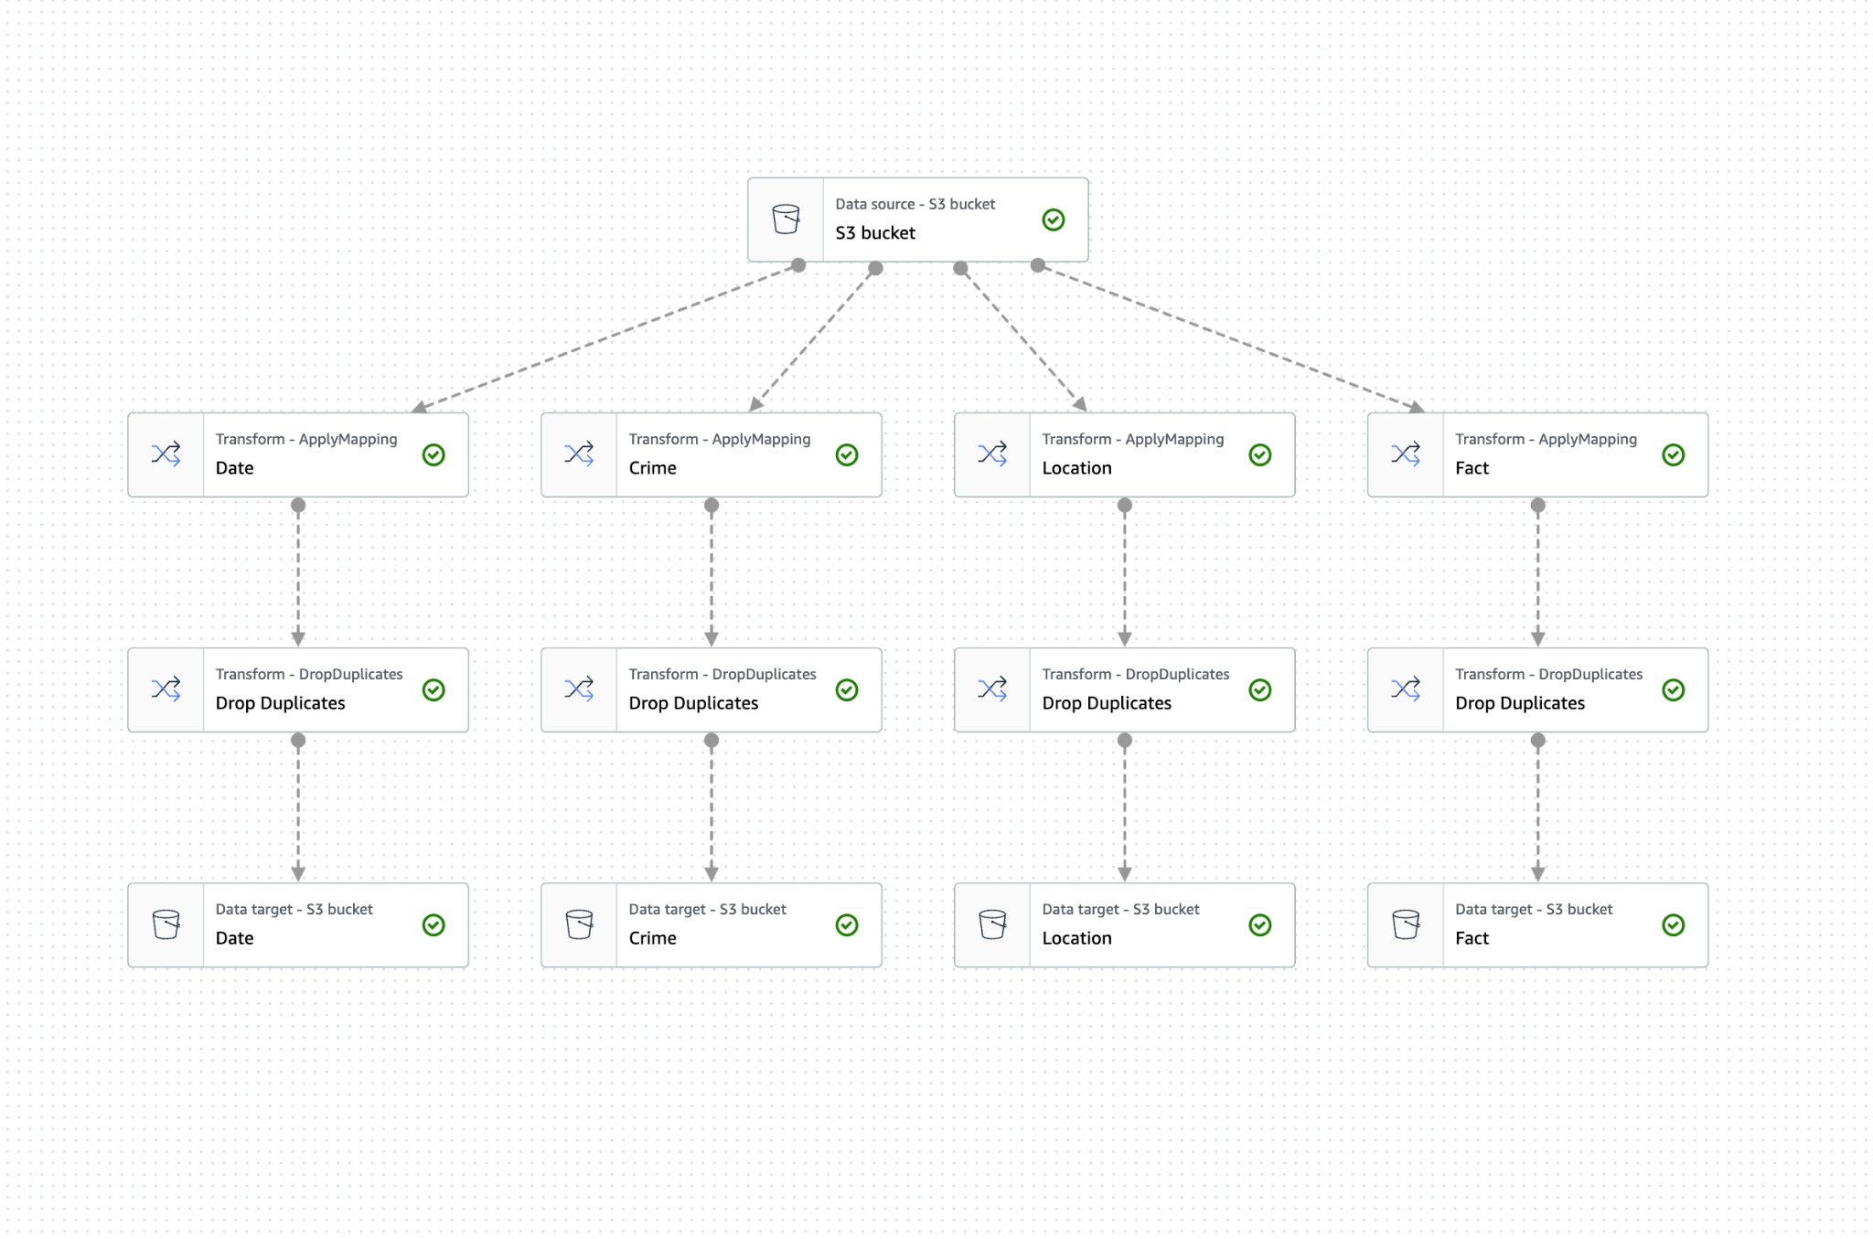

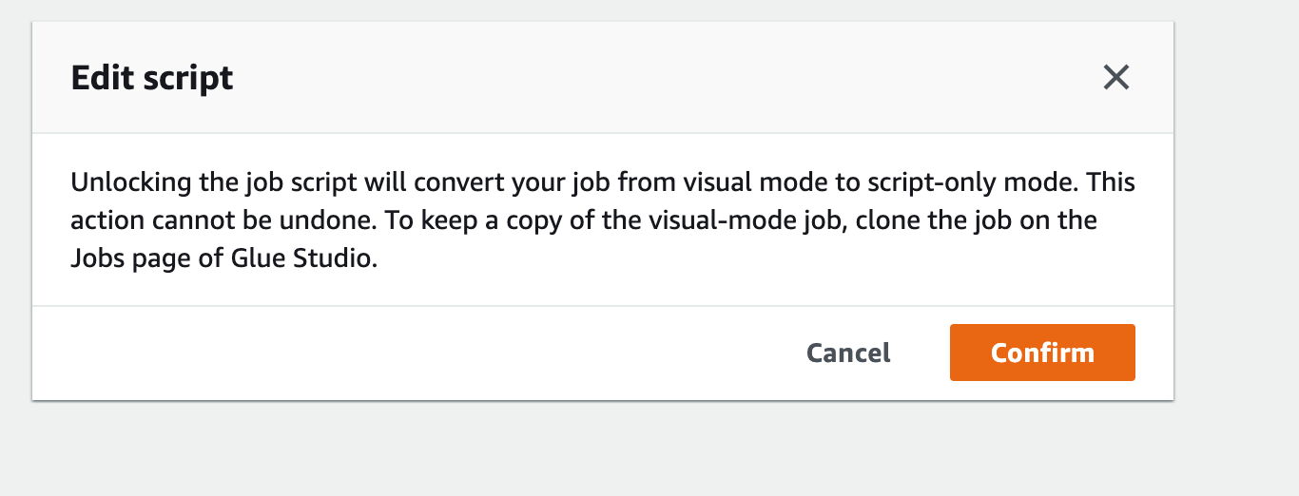

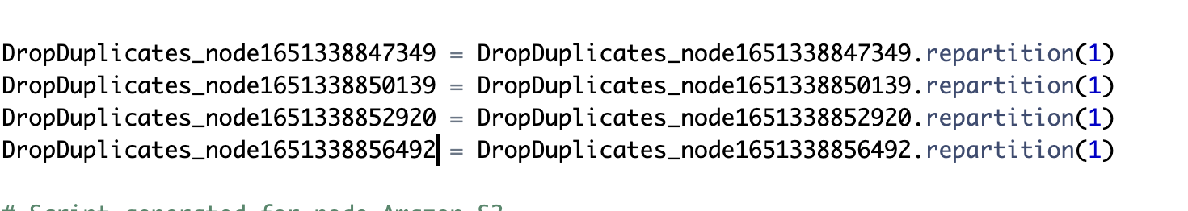

After creating job , running it created various files in the s3 JOB OUTPUT BUCKET .

Created Redshift Iam role with Attach permissions policy page appears. Choose AmazonS3ReadOnlyAccess and AWSGlueConsoleFullAccess.

Created cluster in the redshift and associated the above created IAM role to it.

COPY dev.crime.location FROM 's3://crimes-output-job-bucket/Location' IAM_ROLE 'arn:aws:iam::113131008952:role/redshift-user-role' FORMAT AS CSV DELIMITER ',' QUOTE '"' IGNOREHEADER 1 REGION AS 'us-east-1'

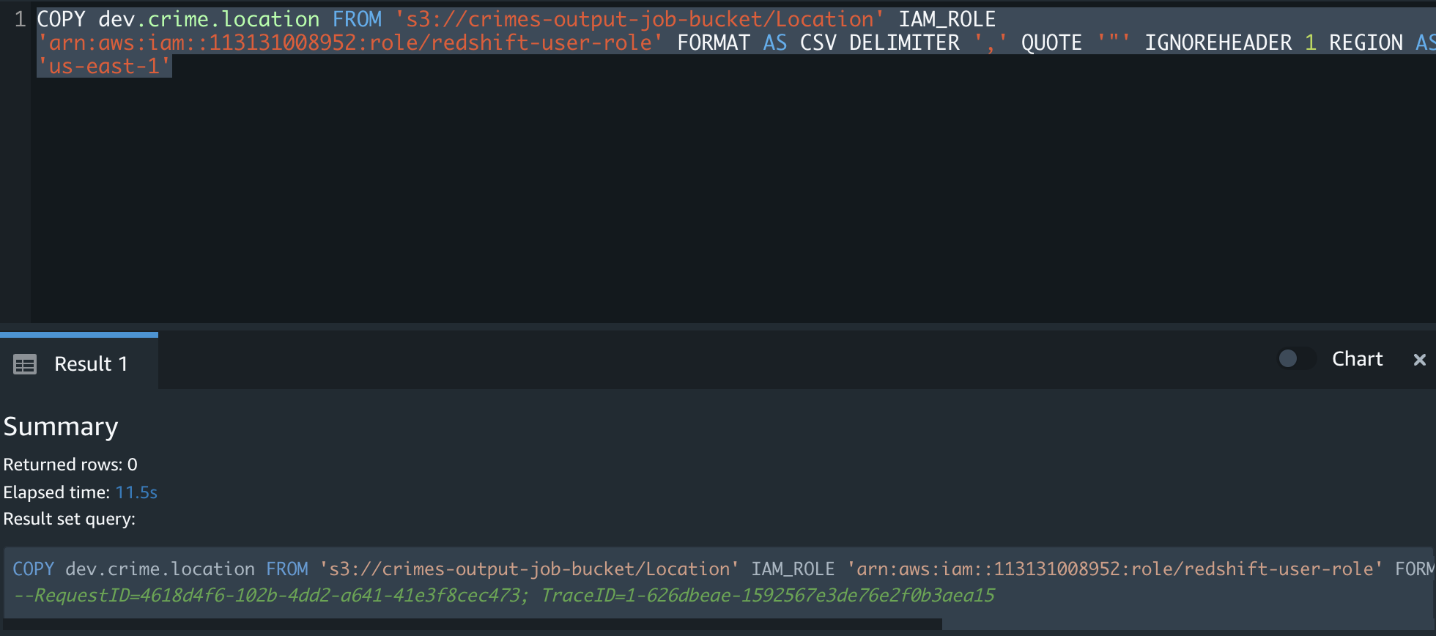

COPY dev.crime.date_of_incident ("date_incident_occurred", month, time, year, date, day, "date_id") FROM 's3://crimes-output-job-bucket/Date' IAM_ROLE 'arn:aws:iam::113131008952:role/redshift-user-role' FORMAT AS CSV DELIMITER ',' QUOTE '"' REGION AS 'us-east-1' IGNOREHEADER 1;

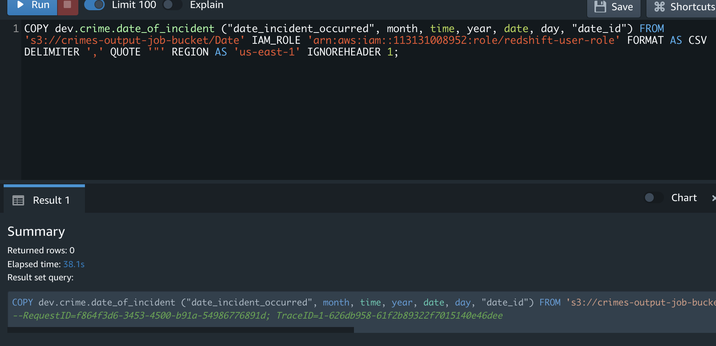

COPY dev.crime.crime (crime_description, crime_id) FROM 's3://crimes-output-job-bucket/Crime' IAM_ROLE 'arn:aws:iam::113131008952:role/redshift-user-role' FORMAT AS CSV DELIMITER ',' QUOTE '"' IGNOREHEADER 1 REGION AS 'us-east-1'

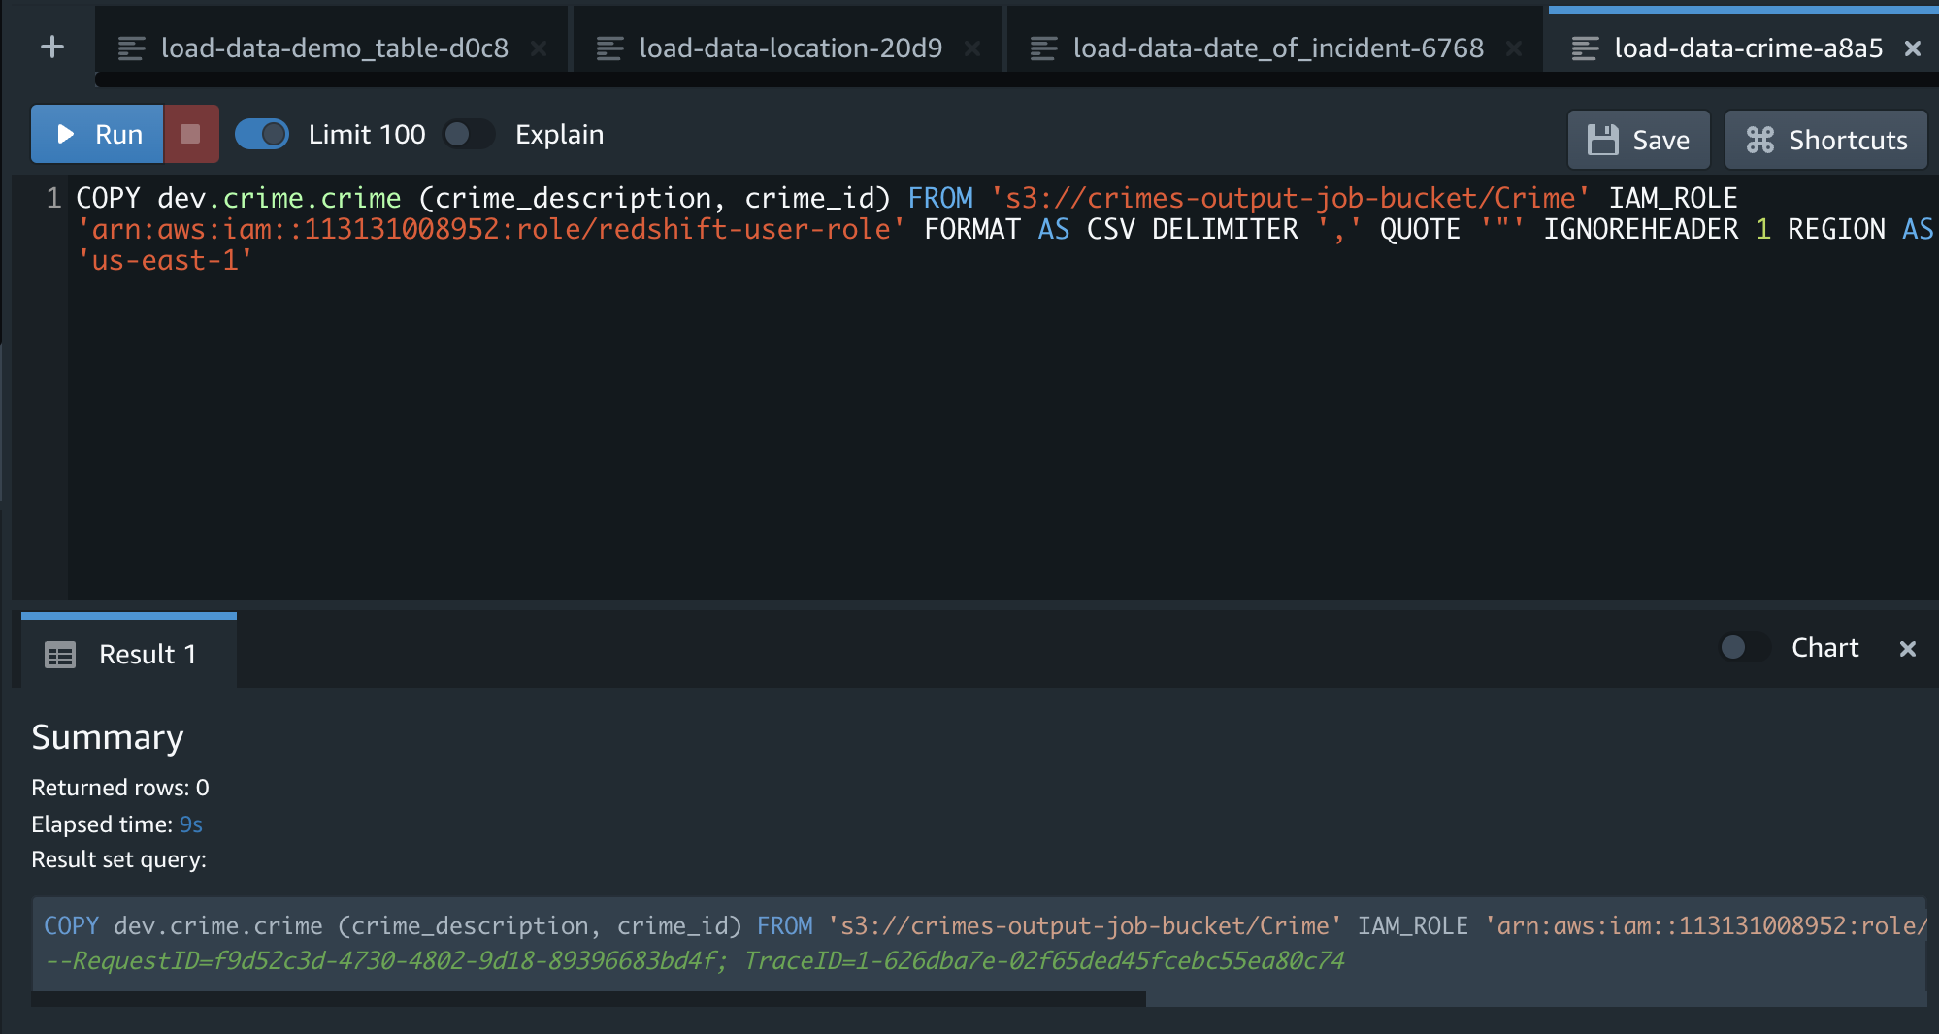

Create Fact table:

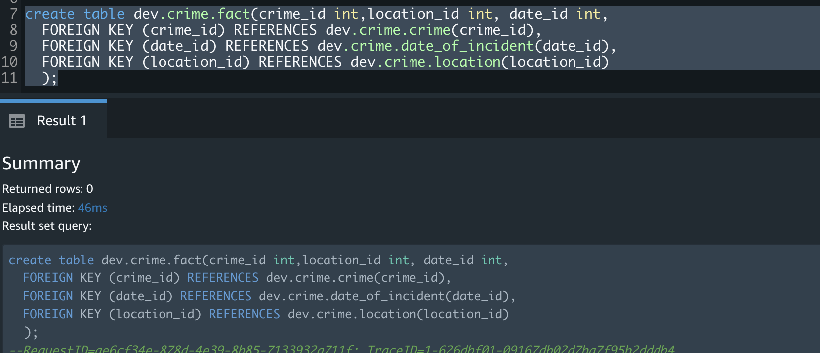

**Pauses:**

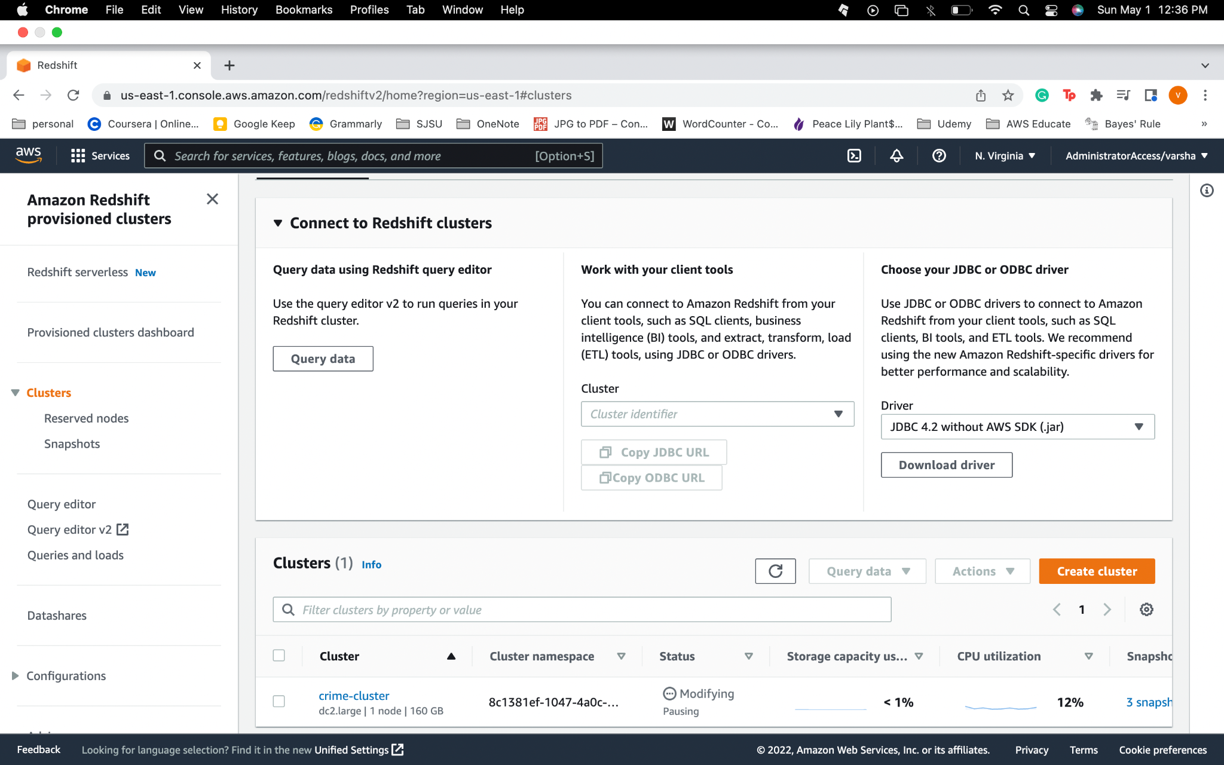

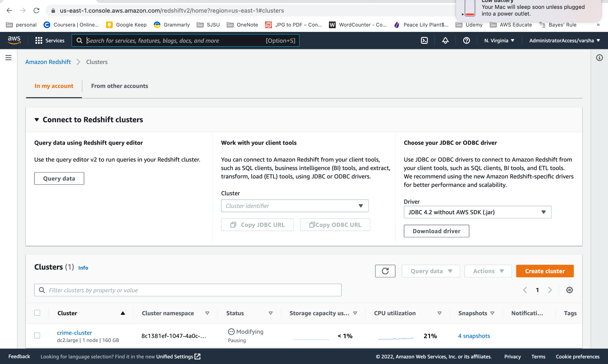

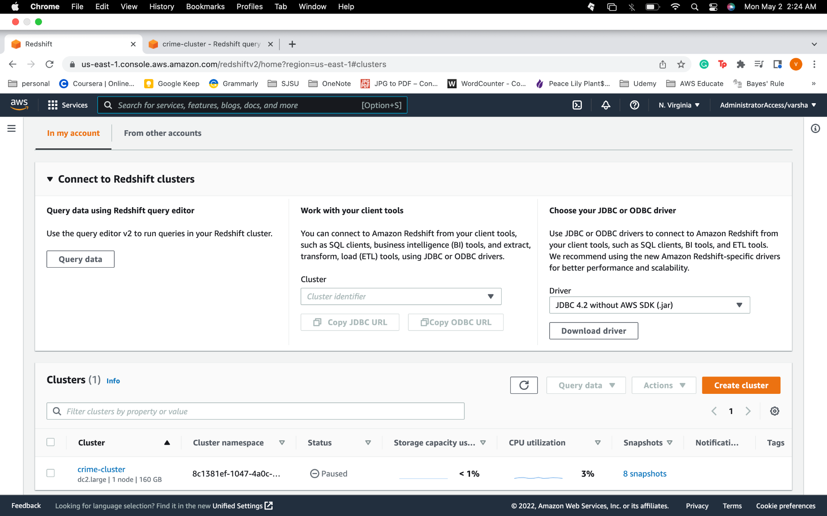

**Resume:**

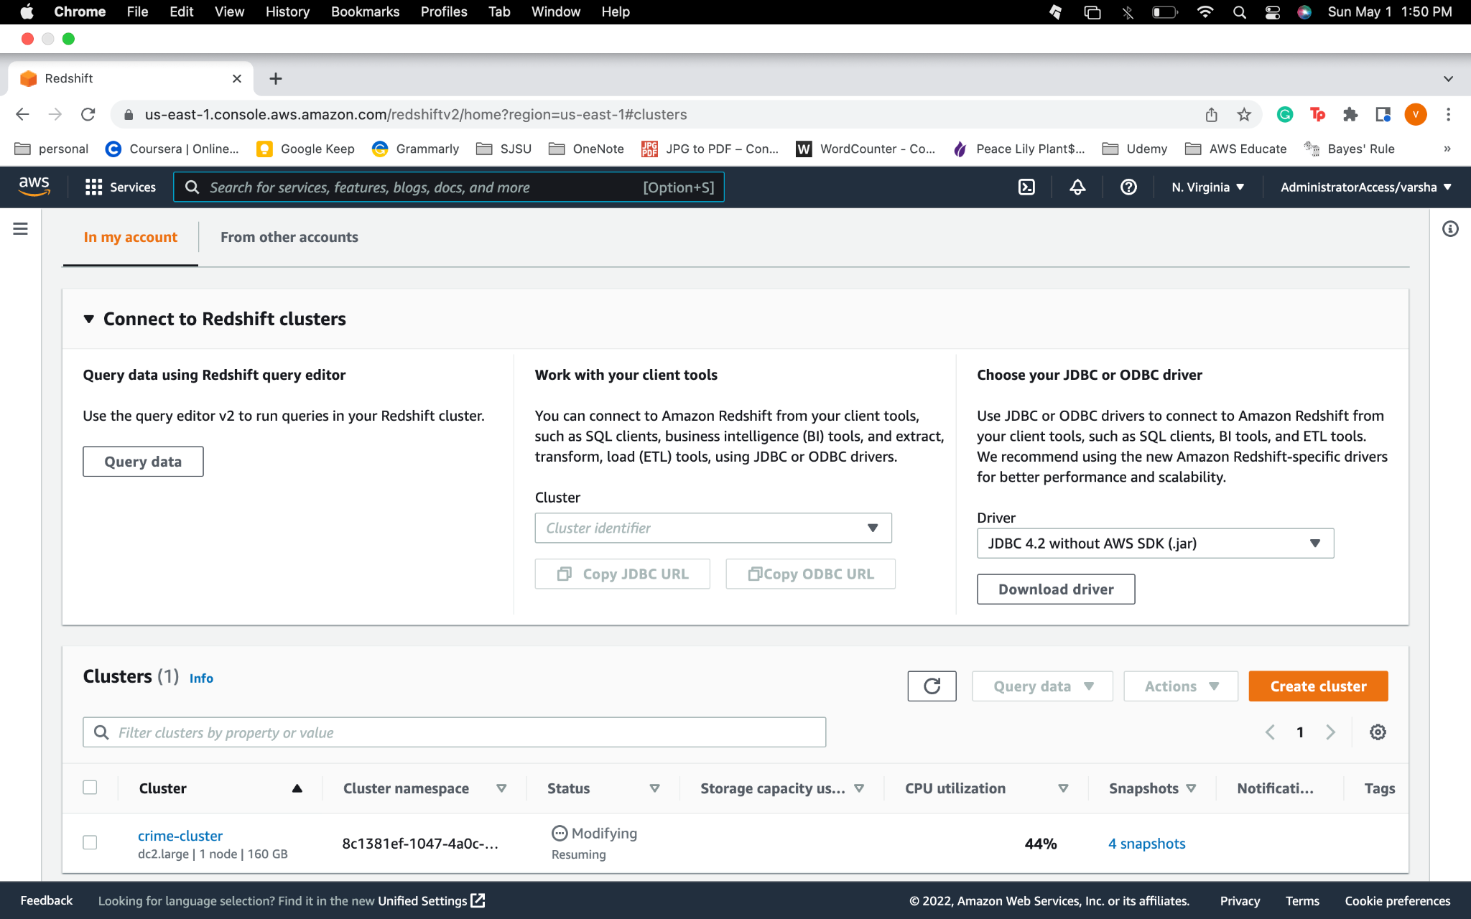



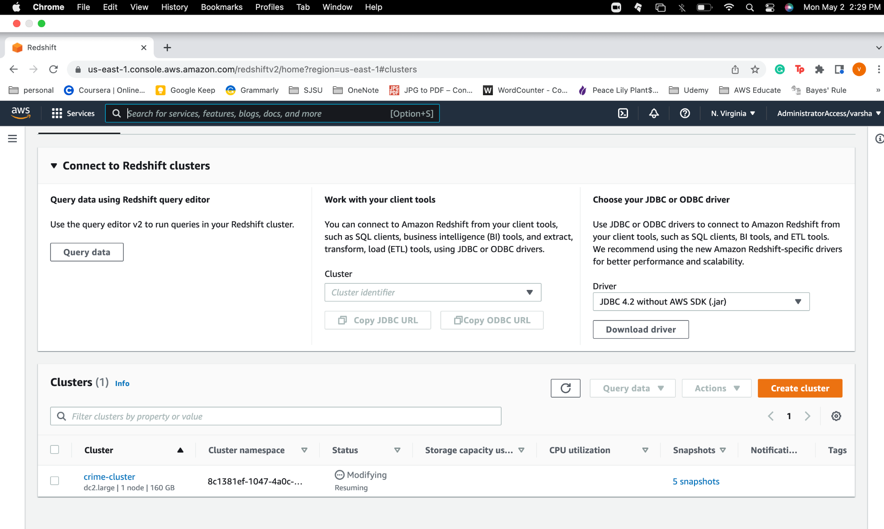

**Queries:**

* Top 5 blocks where more crimes were committed

SELECT "crime"."fact"."location_id", "crime"."location"."block", "crime". "location"."location_description","crime". "location"."latitude","crime"."location"."longitude", "crime"."location"."city", count("crime"."fact"."crime_id") as crime_count

FROM "crime"."fact", "crime"."location"

WHERE "crime"."fact"."location_id" ="crime". "location"."location_id"

GROUP BY "crime". "fact". "location_id", "crime". "location". "block", "crime"."location"."city", "crime". "location". "location_description", "crime". "location". "latitude", "crime". "location"."longitude"

ORDER BY crime_count desc limit 5;

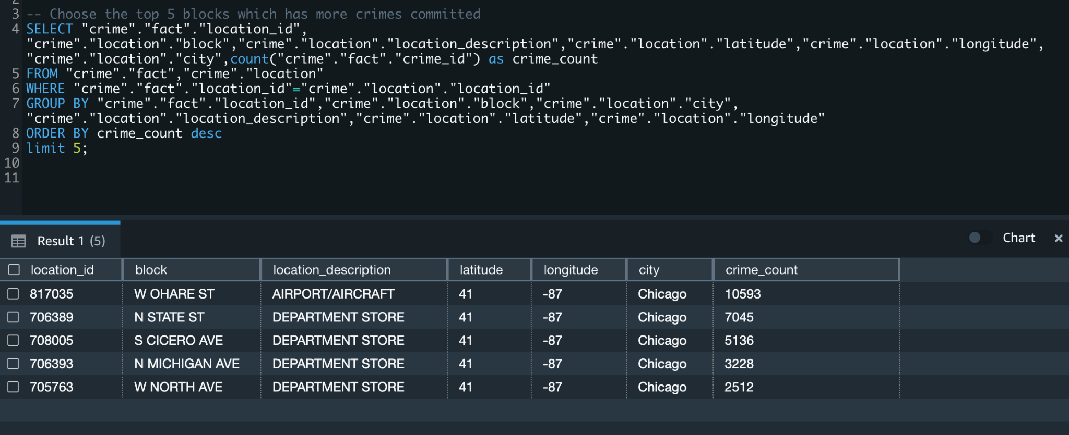

* Total count of offense types

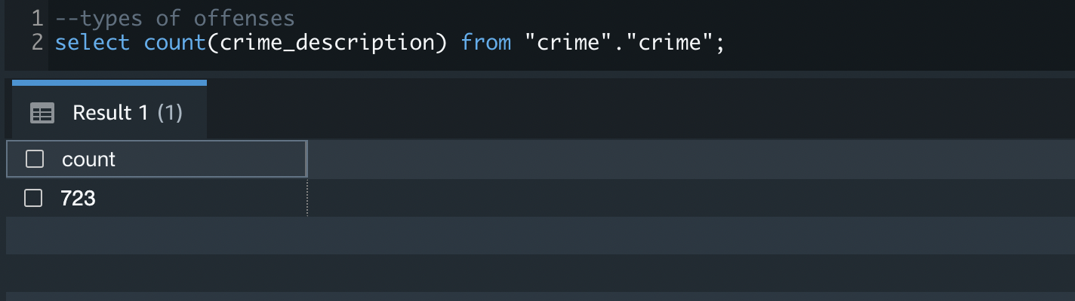

* Types of offenses

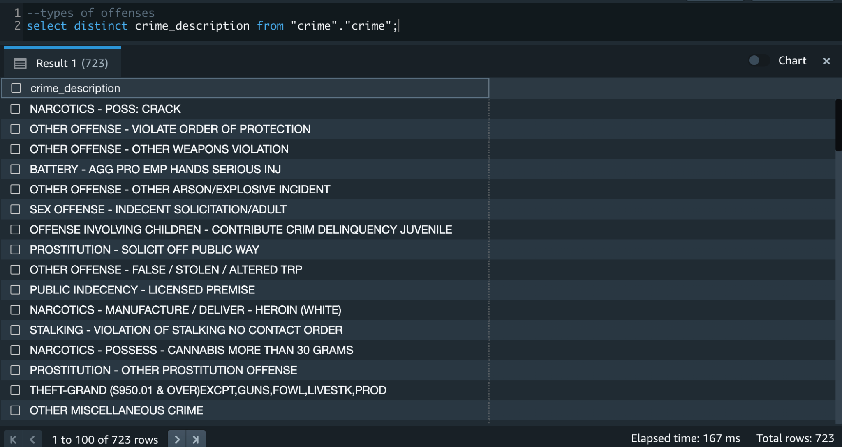

* Count of each offence type

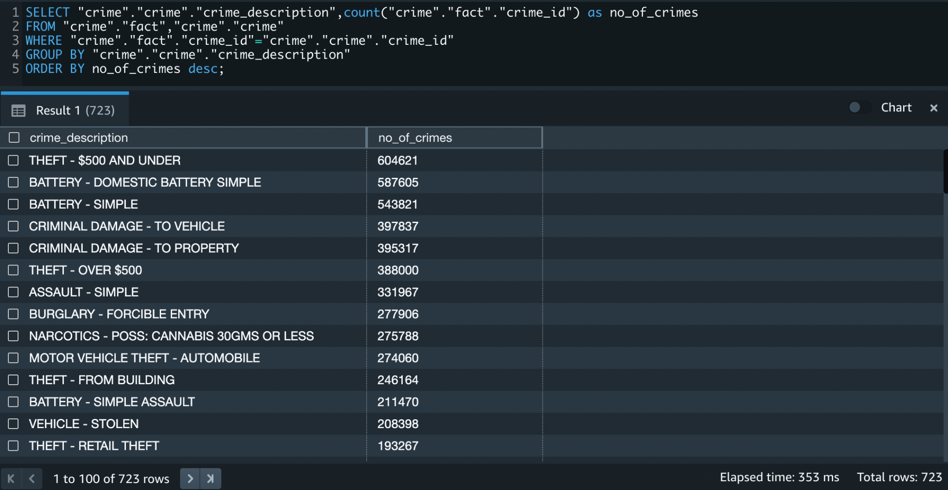

* Least crimes committed locations (least 10)

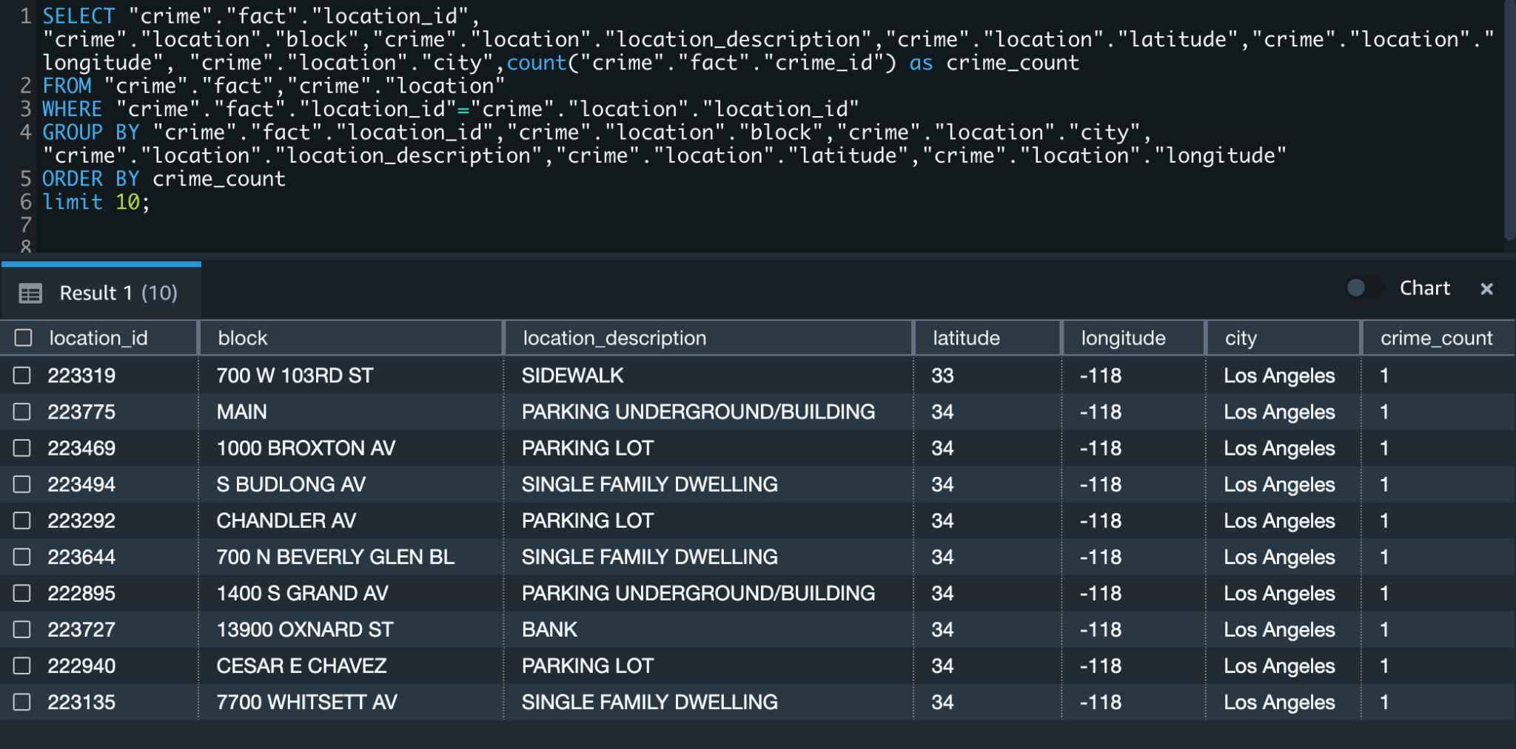

* **Total number of crimes in LA and chicago**

SELECT "crime". "location"."city", count("crime". "fact"."crime_id") as crime_count

FROM "crime". "fact", "crime"."location"

WHERE "crime". "fact"."location_id"="crime"."location"."location_id"

GROUP BY "crime". "location"."city"

ORDER BY crime_count desc;

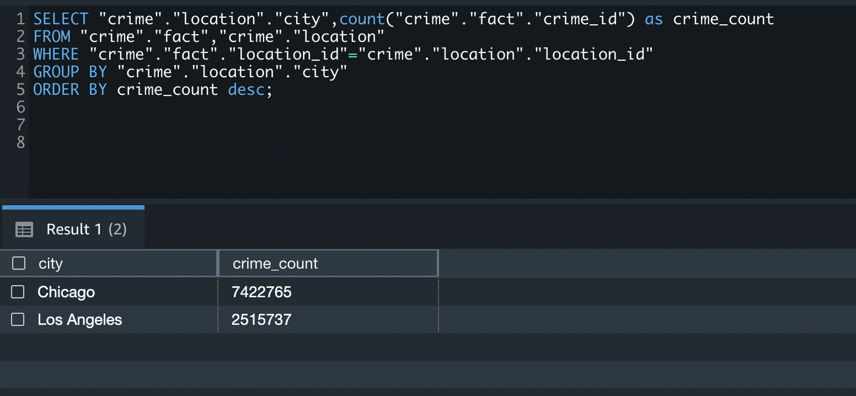

* **Most committed and least committed crime**

(SELECT "crime"."crime"."crime_description", count("crime"."fact"."crime_id") as crime_count, 'Most committed crime' as

crime_count_type

FROM "crime"."fact","crime"."crime"

WHERE "crime"."fact"."crime_id"="crime"."crime"."crime_id"

GROUP BY "crime"."crime"."crime_description"

order by crime_count desc limit 1)

UNION

(SELECT "crime"."crime"."crime_description", count("crime"."fact"."crime_id") as crime_count, 'Least committed crime'

FROM "crime"."fact","crime"."crime"

WHERE "crime"."fact"."crime_id"="crime"."crime"."crime_id"

GROUP BY "crime"."crime"."crime_description"

order by crime_count limit 1);

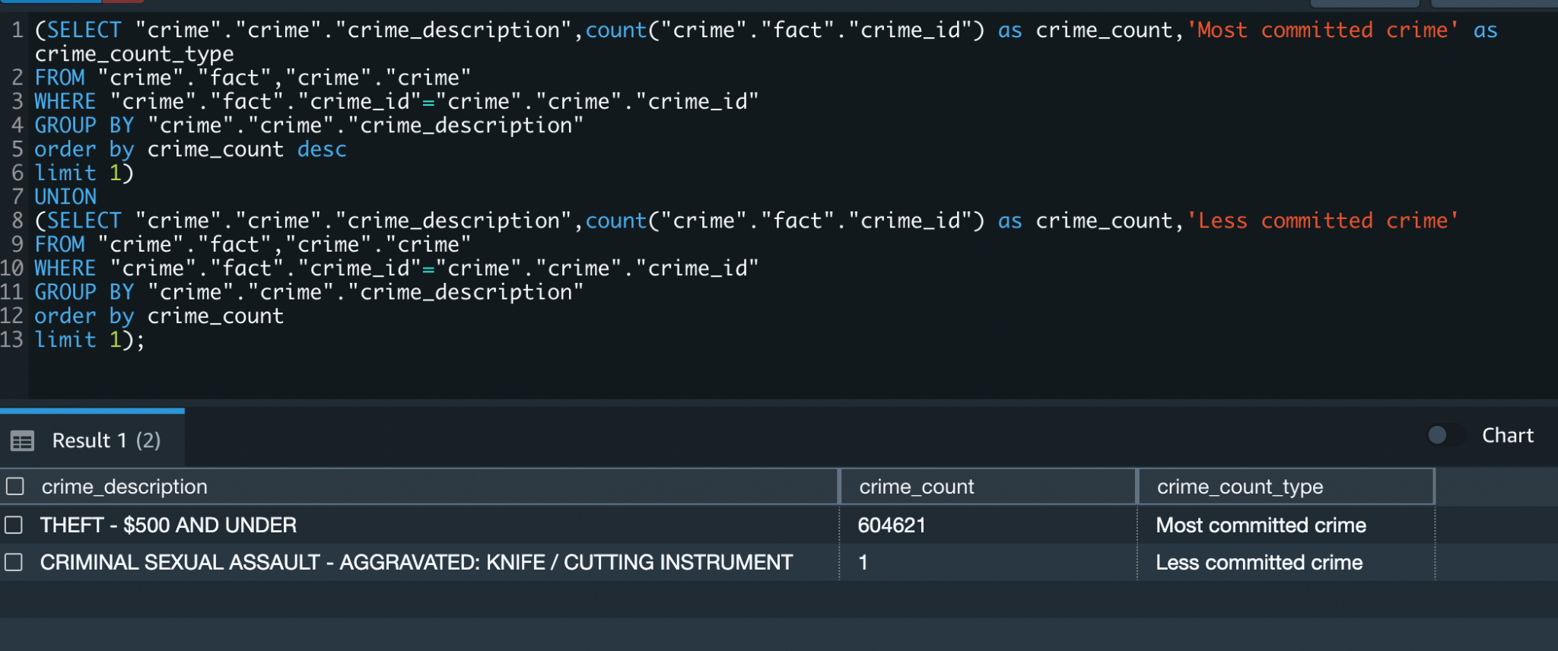

* Total number of crimes during each month (for all years)

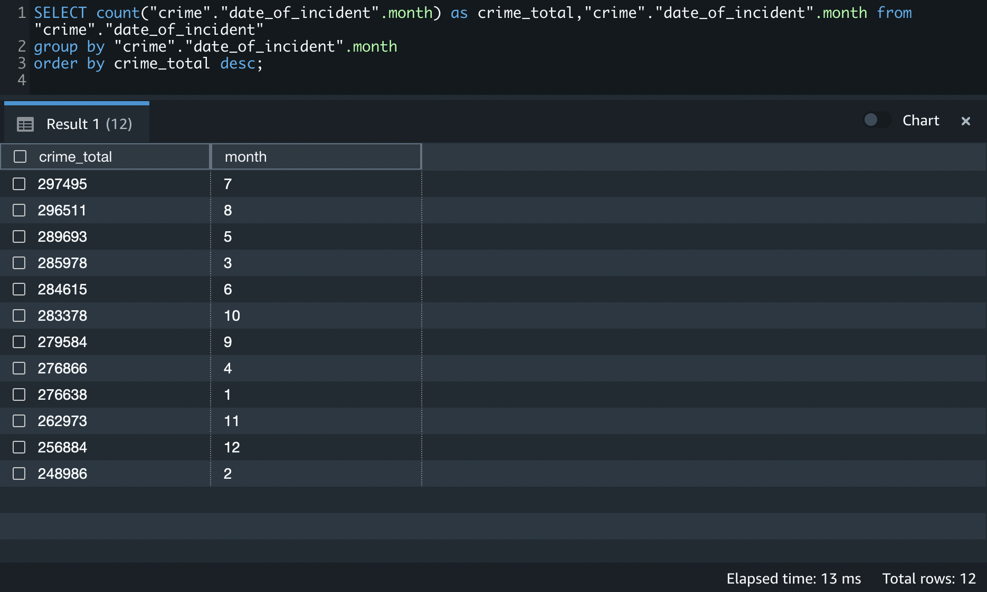

* Crime rates over the years

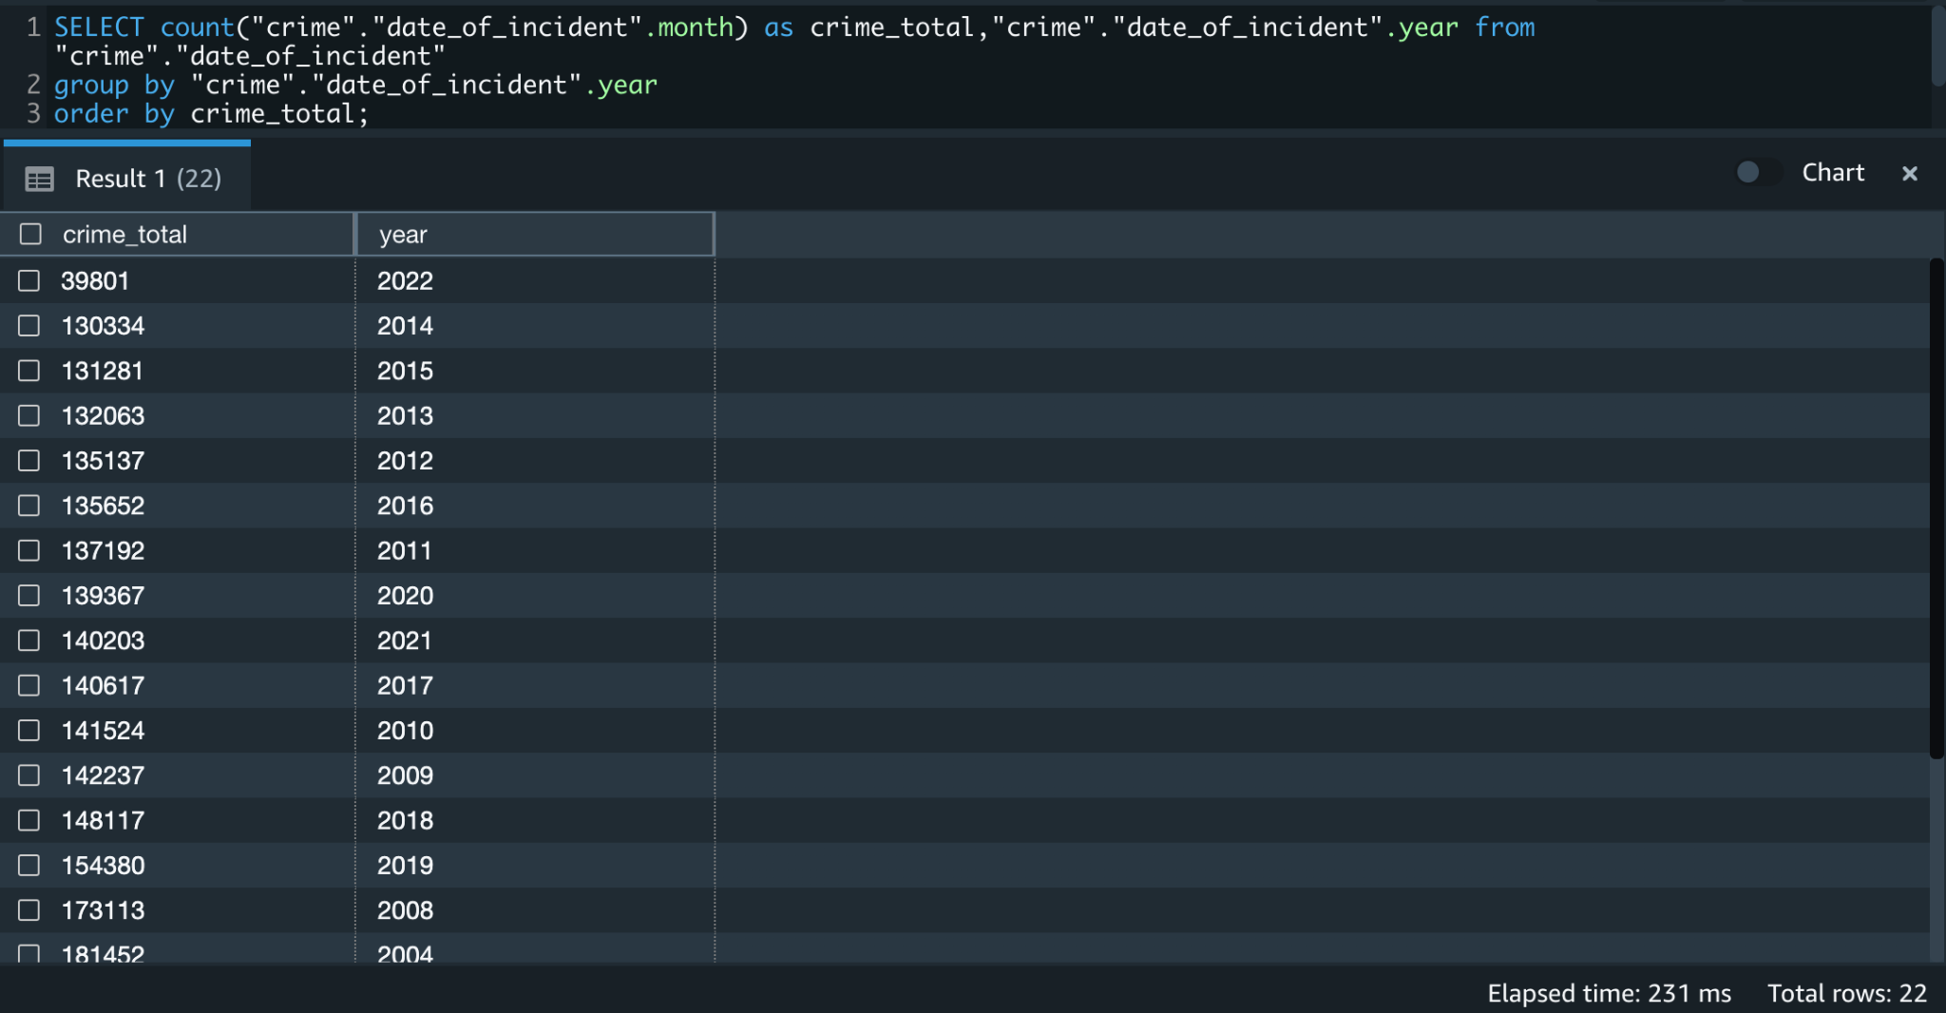

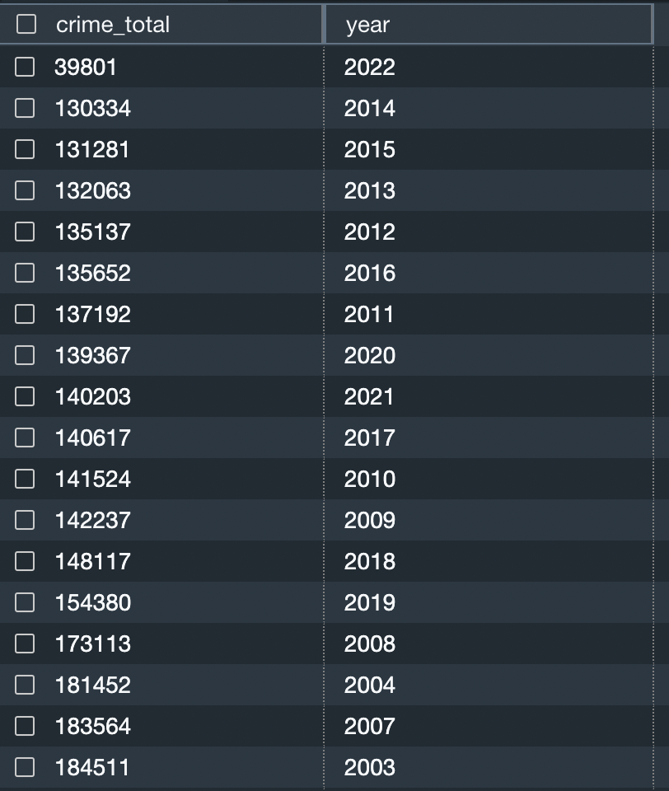

**--Total number of crimes during each month (for all years)**

**SELECT count("crime"."date_of_incident".year) as crime_total,"crime"."date_of_incident".year, "crime"."date_of_incident".month from "crime"."date_of_incident"**

**group by "crime"."date_of_incident".year,"crime"."date_of_incident".month**

**order by "crime"."date_of_incident".year;**

* Year in which maximum crime was committed along with the month range

SELECT count("crime"."fact"."crime_id") as crime_count,substring("crime"."date_of_incident".time,1,2)

FROM "crime"."fact", "crime"."date_of_incident"

WHERE "crime"."fact"."date_id" ="crime"."date_of_incident"."date_id"

group by "crime"."date_of_incident".time;

